**DIGITAL HEALTH ANALYTICS**

**IMPLEMENTATION REPORT**

**NAME: OJO ABIODUN JOSEPH**

**STUDENT ID:C3006883**

TABLE OFCONTENTS

CHAPTER 1 INTRODUCTION..................................................................................................................................1 CHAPTER 2 PROBLEMANALYSIS..........................................................................................................................1 CHAPTER 3

SOLUTION REQUIREMENTS ...........................................................................................................2

CHAPTER 4

IMPLEMENTATION OF SOLUTION.................................................................................................2 CHAPTER 5

PROGRAM EXECUTION ...................................................................................................................3 CHAPTER 6

PROGRAM STRUCTURE FLOWCHART .......................................................................................4

CHAPTER 7 REFLECTION ...............................................................................................................5

**CHAPTER 1 INTRODUCTION**

Digital health is transforming not only how people’s health is managed but also helping to prevent avoidable deaths. From translating health data and care into actions, it is gradually becoming an integral part of how health care providers and patients themselves manage health related problems. In addition, the availability of network enabled devices such as smartphone and wearable devices is enabling mobile medical apps and software that can provide support for clinicians to make clinical decisions using available data and artificial intelligence (AI) or machine learning (ML).

The project looks at developing an interactive interface that will allow user to select from range of selection what vital health information they want to see. The project is divided into three part, the first part is where the data is loaded, the second part of the project looks at creating a query modules that contains all function and method the program want to solve and the last which is the third part contain the user interface where all the interaction of the query module, the data set, the menu selection, and the display code reside

**CHAPTER 2 PROBLEM ANALYSIS**

The project is to design and analyze this dataset, and then design and implement an application that can help clinicians monitor patients’ vital signs such as blood pressure, etc. to prevent an impending fatality.

The implementation of the project will be looking at been able to:

* Compute the average age, modal age, median age of those whose heart failure resulted in death.
  + Compute the average time taken for those whose heart failure did not result in death.
  + Compute the median age, average age, and modal age of those with high blood pressure.
  + Compute the median age, average age, and modal age of those with diabetes.
  + Determine whether diabetes is linked to smoking and high blood pressure.
  + Compute the average serum sodium of those with diabetes.
  + Determine if anaemia is linked to smoking or not.
  + Returns anyone without high blood pressure that died of heart failure.
  + Computes and returns the IQRs (Interquartile Range) of ejection fraction and serum creatinine.
  + Compute and return the sample variance of creatinine phosphokinase and serum sodium.
  + The outputs of any of these functions should be persisted into an external file in csv format.

This will be achieved through proper plan of all parameter, function, method and modules that will be used.

**CHAPTER 3 SOLUTION REQUIREMENT**

The project solution plan is divided into three part

1. **Loading the data and this involves**
   1. Implementing a function to read the data
   2. Implement a function to hand exception and error while load
   3. Implement a function that read the csv file in a format required
   4. Introduced a variable called id
   5. Convert the data to required data type for better out put
2. **Implement a Query Module**
   1. Implement a filter function
   2. Implement function for every problem to be solved
3. **Implement User Interface Module**
   1. Implement a function that display what the user wants to select and see (**display menu**)
   2. Implement a function that allow user to input there choice (main function)
   3. Implement a try function
   4. Implement a function that handle user choice
   5. Implement a filter function that handle the death data set
   6. Implement all the display function

**CHAPTER 4 IMPLEMENTATION OF SOLUTION**

The implementation started by first creating a function that will be use to read the data set for the project. The program also uses exceptional handling to handle exception and error and it is used in the project at different part for different error capturing for example when used during loading of the data set it is expected to block any exception if the file is not found. The program introduce csv.DictReader which allow the data to be read but maps the information read into a dictionary. The variable called id was introduced which makes every entry a unique entry and for proper outputting the data was also formatted to required data format for easy calculation and output.

The second part of the project involved the query module implementation which is the part involved with implementation of all function that defined the question the project will be solving. And also a filter function was created to filter condition to be used in the program from the data set.

The third part of the project which is the **User Interface Module**, this module contains many functions that make it easy for user to interact with the program. One of the functions is the display menu faction that display choice of different statistics that the user will like to see. Another function is the is the **main function** that display an interface that allow user to input that choice based on the information they want to see. The **process choice function** is one vital function in the project that host the choice of the user and it interact with the display function to output the required information needed by the user and the display function interact with the query module to fetch required statistics

**CHAPTER 5 PROGRAM EXECUTION**

The execution of the project start from loading the data, to running the interface and user inputting there choice and this also represented or shown on the chart in chapter 6.

The project file is downloaded in two format and it is .py and .ipynb. both file contain the whole document. To run this program the data set, the project .py file, must be in the same folder for the program to run. The first thing is to import Final_PCP_Solution_Project, then from Final_PCP_Solution_Project import QueryModule and UserInterface, also from Final_PCP_Solution_Project import clinical_data, then query_module = QueryModule(clinical_data) , also run user_interface = UserInterface(query_module), and then run user_interface.main()

The first thing to do is to import the fil

**CHAPTER 6 PROGRAM STRUCTURE CHART**

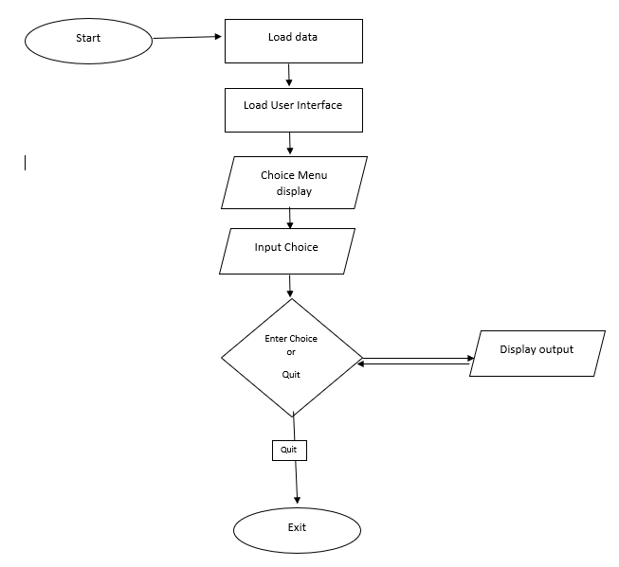**CHAPTER 7 REFLECTION**

The project has shown me how a real word problem is solved because before now I have the understanding but this put everything together especially the interaction part of the project but it was not easy getting there because I faced a lot of issues bringing it together. I will say it as contributed greatly to my development and personal will want to still work on personal project that can help me grow in solving problem using data and interactive programming.

There were challenges at every point of solving the project solution which include not changing the data type to give required output and many more. With this expose I believe it’s a big add of knowledge to me and development and will try my best to practise more so it sticks totally.